DEVELOPMENT OF A SMART AI RECYCLE BIN WITH FILL-LEVEL MONITORING AND NOTIFICATION

BY

FAJIMI KOLADE INIOLUWA
(2020/9207)

BELLS UNIVERSITY OF TECHNOLOGY, OTA
JULY, 2025

DEVELOPMENT OF A SMART AI RECYCLE BIN WITH FILL-LEVEL MONITORING AND NOTIFICATION

BY

FAJIMI KOLADE INIOLUWA
2020/9207

A Project Submitted in Partial Fulfilment of the Requirements for the Award of Bachelor’s Degree of Engineering (B. Eng.) in Mechatronics Engineering at the Department of Mechatronics Engineering, College of Engineering, Bells University of Technology, Ota.

JULY, 2025

DECLARATION

I hereby declare that this research work was carried out under the supervision of Professor Nwanya in the Department of Mechatronics Engineering, College of Engineering, Bells University of Technology, Ota, Nigeria. I affirmed that the dissertation had not been presented either wholly or partially for the award of any degree elsewhere. All bases of data and scholarly information used in this dissertation are duly acknowledged by means of references.

..……………………………………..
FAJIMI KOLADE INIOLUWA

..……………………………………..
Date

CERTIFICATION

I certify that this project titled "DEVELOPMENT OF A SMART AI RECYCLE BIN WITH FILL-LEVEL MONITORING AND NOTIFICATION" is an original research work carried out by FAJIMI KOLADE INIOLUWA (2020/9207) in the Department of Mechatronics Engineering, College of Engineering under my supervision. I have examined.

……………………………… Date ……………………………
Prof. Stephen Nwanya
(Project Supervisor)

……………………………… Date ……………………………
Dr. Chinedu Ezugwu
(Head of Department)

ACKNOWLEDGEMENTS
My profound gratitude goes to the Almighty God, who, in His infinite mercy, granted me the wisdom, knowledge, and understanding, as well as the strength and good health, to complete this project.
I would like to express my sincere appreciation to my project supervisor, Prof Stephen Nwanya for their unwavering support, constructive criticism, and invaluable guidance throughout the course of this research. Their expertise and encouragement were pivotal to the successful realization of this project.
I am immensely grateful to the Head of Department, Dr. Chinedu .A.K. Ezeugwu, and particularly to the Dean of the College of Engineering, Prof Ojo S Fayomi, for their leadership, support, and for fostering an environment conducive to academic excellence. My thanks also extend to all the lecturers in the Department of Mechatronics Engineering, Bells University of Technology, Otta, for their dedication to imparting knowledge.
My heartfelt thanks also go to my beloved parents, siblings, and family members for their constant prayers, financial support, and moral encouragement, which served as a source of inspiration during challenging times.
Finally, I extend my appreciation to my friends, colleagues, and all who contributed directly or indirectly to the success of this project. Your support, insights, and companionship made this journey more enriching.

ABSTRACT
The existing waste crisis in an increasing number of countries around the world, in particular, in the developing countries such as Nigeria, is characterized by inefficient manual segregation, the inability to monitor the sorting process in real-time and the contamination of the materials being sorted out, which creates both environmental concerns and a risk to the health of the population. This project will answer these questions by creating and developing a Smart AI Recycle Bin that will also have automated waste classification, real-time fill-level monitoring, and notification capabilities. With a design-and-build approach, the system combines a Raspberry Pi 5, ultrasonic, and sensor components, a pair of servo and stepper motors, and a Picamera 2 to fit a neural network AI, an EfficientNet-Lite-model, powered through TensorFlow Lite to perform classifications of waste on the same device. Firebase is used to synchronize data in real-time and send notifications, and a mobile application built on Flutter is the actual user interface. Testing of the prototype showed that it has a classification accuracy of about 94 percent, it can give reliable fill-level readings, and it can generate near-real time notifications, which have the effect of making recycling more efficient and cutting down on contamination. The system is a new and data-driven, autonomous product that improves the waste management of a city, reduces human labor, and preconditions smart city infrastructures of waste management at scale.

Word Count: 218.

.

TABLE OF CONTENTS
DECLARATION iii
CERTIFICATION iv
ACKNOWLEDGEMENTS v
ABSTRACT vi
LIST OF FIGURES x
CHAPTER ONE: INTRODUCTION 1
1.1 Background of the Study 1
1.2 Statement of the Problem 3
1.3 Aim and Objectives of the Study 4
1.4 Justification of the Study 5
1.5 Scope of the Study 6
1.6 Limitation of the Study 7
CHAPTER TWO: LITERATURE REVIEW 9
2.1 Waste Management Challenges 9
2.2 Role of AI in Waste Management 10
2.3 IoT for Real-Time Monitoring 12
2.4 Smart Recycling Systems 14
2.5 Case Studies 16
CHAPTER THREE: METHODOLOGY 18
3.1 Research Design 18
3.2 System Development 20
3.2.1. Hardware Components 20
3.2.2. Software Components: 36
3.3 Data Collection and Training 39
3.4 Testing and Evaluation 40
3.4.1 Controlled Lab Tests 40
3.4.1 Real-World Deployment 41
3.5 Data Analysis 42
CHAPTER FOUR: RESULTS AND DISCUSSION 44
4.1 Introduction 44
4.2 System Design and Implementation Overview 44
4.3 Hardware Component Performance 46
4.3.1 Ultrasonic Sensors 46
4.3.2 Servo Motors 47
4.3.3 NEMA 17 Stepper Motor 47
4.3.4 Raspberry Pi 5 48
4.3.5 Raspberry Pi Camera Module 48
4.4 Software Component and AI Model Performance 49
4.4.1 EfficientNet-Lite AI Model 49
4.4.2 Training and Validation Performance Analysis 50
4.4.3 Confusion Matrix Analysis 52
4.4.3 Firebase Integration: 54
4.4.4 Flutter-Based Mobile Application 54
4.5 Fill-Level Monitoring Results 55
4.6 System Evaluation and Discussion 56
4.6.1 Key strengths 56
4.6.1 Limitations: 57
4.6.3 Comparison with traditional systems 58
CHAPTER FIVE: CONCLUSION AND RECOMMENDATION 59
5.1 Conclusion 59
5.2 Recommendations 61
5.3 Future Work 63
REFERENCES 65

LIST OF FIGURES
Figures Page
Figure 3.1 PCA9685 21
Figure 3.2 DRV8825 23
Figure 3.3 Stepper motor driver control board 24
Figure 3.4 Breadboard 26
Figure 3.5 Jumperwires 27
Figure 3.6 HC-SR04 Ultrasonic sensor 29
Figure 3.7 Raspberry Pi 5 31
Figure 3.10 NEMA 17 Stepper motor 35
Figure 3.11 Python code sourced from ai used in building the model 37
Figure 3.12 Python code used in training the model 38
Figure 4.1 Training Loss vs Accuracy 50
Figure 4.2 Confusion Matrix 53

CHAPTER ONE

INTRODUCTION

1.1 Background of the Study
The world is currently facing a rapidly growing waste problem. This serious issue is mainly made worse by the fast growth of cities, a huge increase in the global population, and our continued use of old-fashioned ways to manage trash. The United Nations Environment Programme (UNEP) reports that over 2 billion tons of municipal solid waste are produced worldwide each year. What's especially troubling is that only about 13.5% of this waste actually gets recycled a statistic that reflects a critical shortfall in global recycling efficiency (UNEP, 2021). This huge inefficiency directly causes serious harm to our environment. We see widespread plastic pollution choking our oceans, more greenhouse gases coming from landfills, and a quicker drain on our planet's natural resources. The situation is particularly tough in developing countries like Nigeria, where a population of over 200 million together creates an estimated 32 million tons of waste annually, but less than 15% of it goes into proper recycling systems (LAWMA, 2020; UNEP, 2021).
In Nigeria, waste management still heavily depends on informal systems. Here, waste pickers are at the very heart of the system, manually searching through unsorted dumpsites and unofficial collection spots to find valuable items like plastics, metals, and paper. While their efforts are absolutely essential to the current recycling setup, the methods they use are very inefficient. This work is not only incredibly demanding physically and time-consuming; it also exposes these individuals to serious health risks, including injuries from sharp objects, respiratory condition from toxic fumes, and infections from hazardous waste (Ogbonna et al., 2019; Ahsan et al., 2019). On top of this, they earn very little and inconsistent income, often just enough to survive.
Beyond specific regions, traditional recycling systems worldwide struggle with deep-seated problems that make these issues worse. Manual sorting, for instance, is still a common method, but it's naturally prone to mistakes. These errors often lead to recyclables being contaminated (meaning they get mixed with things they shouldn't). Reports from various cities show that contamination rates can be quite high often between 25% and 40% which significantly reduces both the market value and the potential for true recycling (EPA, 2021; SWANA, 2019). Often, entire batches become unusable, putting further strain on recycling facilities. This situation discourages effective recycling efforts, contributes to more waste being dumped in landfills, and increases environmental pollution from leachate and methane emissions.
However, promising and potentially game-changing solutions are now emerging through new technologies especially Artificial Intelligence (AI) and the Internet of Things (IoT). AI programs using computer vision and deep learning can classify waste with high speed and accuracy, thereby reducing human dependency and improving material purity (Liu et al., 2021). Simultaneously, IoT sensors allow for continuous monitoring of fill levels in real-time, enabling optimized collection schedules and lower fuel consumption (Reddy & Kumar, 2020). Together, these technologies have the potential to transform traditional waste management and lay the groundwork for smarter, cleaner cities.

Therefore, this study aims to develop an innovative Smart AI Recycle Bin. This system comes with a built-in Fill-Level Monitoring and Notification System. The system is designed to integrate Artificial Intelligence (AI) for automated and precise waste classification with Internet of Things (IoT) technology to enable continuous, real-time monitoring of bin fill levels. The main goal is to provide a sustainable, efficient, and scalable solution that directly addresses the urgent waste management challenges common in Nigeria and similar developing contexts, ultimately contributing to a cleaner and healthier environment. This detailed background clearly demonstrates the need for such advanced, technology-driven solutions, shaping both the problem statement and the objectives of this study.

1.2 Statement of the Problem
Traditional waste management systems in many developing regions, including Nigeria, remain inefficient due to static collection schedules, manual sorting, and the absence of real-time monitoring infrastructure. These outdated practices result in premature waste collections, overflowing bins, and increased operational costs, while also posing serious environmental and health risks. Manual sorting is especially error-prone, leading to contamination rates of up to 40% (EPA, 2021; Ahsan et al., 2019), which reduce recycling quality and increase processing costs.
The lack of real-time data and automated decision-making limits the ability of waste management teams to respond promptly to fill-level changes or collection needs, further worsening inefficiencies and public health concerns. Additionally, low public awareness and poor participation in recycling initiatives continue to undermine sustainability efforts.
An intelligent, adaptive waste management system capable of real-time monitoring, automated sorting, and smart notifications could address these challenges. By integrating artificial intelligence (AI), Internet of Things (IoT), and cloud-based analytics, such a system can optimize collection routes, reduce operational expenses, and enhance recycling accuracy. This project, therefore, proposes a Smart AI Recycle Bin that intelligently classifies waste, monitors fill levels, and sends real-time notifications to relevant authorities paving the way for efficient, sustainable, and data-driven urban waste management.

1.3 Aim and Objectives of the Study
The aim of this project is to design and develop a Smart AI Recycle Bin that intelligently classifies waste, monitors fill levels in real time, and automatically notifies waste management teams for timely collection. The system seeks to enhance recycling efficiency, reduce environmental pollution, and promote sustainable urban waste management practices.
- To design and train a machine learning model capable of accurately classifying waste into categories such as plastic, paper, metal, and general waste using real-time image processing.
- To integrate IoT-based ultrasonic sensors for continuous and precise monitoring of bin fill levels and to transmit data wirelessly to a cloud-based platform for real-time tracking.
- To implement an automated notification system that sends alerts to waste management personnel when bins reach a predefined capacity threshold, ensuring timely collection and preventing overflow.
- To collect, store, and analyze disposal and usage data to evaluate system performance, identify patterns, and improve future waste management strategies.
- To optimize the system’s energy consumption through efficient component design and low-power operation, enabling long-term deployment and potential use with off-grid power solutions.

1.4 Justification of the Study
The justification for this study arises from the urgent need to modernize waste management systems in developing countries like Nigeria, where traditional methods remain inefficient, hazardous, and environmentally unsustainable. Existing recycling systems rely heavily on manual labor and lack data-driven coordination, leading to high contamination rates, poor sorting accuracy, and overflowing waste bins. These problems not only degrade the environment but also pose serious public health challenges.
By integrating Artificial Intelligence (AI) and the Internet of Things (IoT), this project provides a practical and innovative solution that combines automation, real-time data monitoring, and intelligent decision-making. The Smart AI Recycle Bin minimizes human contact with waste, ensures better classification accuracy, and optimizes collection schedules through fill-level notifications. Moreover, it supports Nigeria’s movement towards smart, sustainable cities and aligns with global efforts to promote environmental responsibility and circular economy principles.

In essence, this study is justified because it bridges a critical technological gap in local waste management practices by offering a scalable, affordable, and efficient system that enhances both environmental protection and operational performance.

1.5 Scope of the Study
The idea of this study is to design, develop, and test a prototype Smart AI Recycle Bin system with automatic waste sorting, real-time fill-level indicator, and notification capability. The project will solve the urban waste management problems, especially in offices, schools, and places in a developing area. What this project covers includes these main areas:
- Hardware Development
This means carefully choosing and putting together all the parts it needs. This includes good ultrasonic sensors for knowing how full the bins are, a sharp camera for seeing what the trash is, strong servo motors for the automatic lid and dumping trash well, and accurate stepper motors to spin the inside parts just right. Plus, a powerful Raspberry Pi 5 microcontroller will be there to run everything.
- Software Development
This big part is all about the software. It involves building and carefully training a smart machine learning model (based on EfficientNet-Lite) that's made to be super accurate at sorting trash. Also, we'll connect it smoothly to Firebase, an IoT platform. This makes sure we get constant monitoring, safe data sending, and instant alerts. On top of that, the system has strong background programming to manage sensor signals, motor controls, and talk to the cloud.

- Testing and Optimization
This phase involves comprehensive performance evaluation conducted in a dual approach: initial rigorous testing in controlled laboratory environments to verify baseline functionality and component performance (e.g., isolated sensor accuracy, motor precision), followed by extensive real-world trials. These real-world evaluations in pilot settings focus on assessing overall system accuracy, operational latency, long-term reliability, and general user satisfaction under actual usage conditions.
- Mobile App Integration
A prototype Flutter-based mobile application was concurrently developed. This application serves as the primary user interface, providing a visual dashboard to intuitively display real-time bin status, current fill levels (often represented through dynamic graphs), historical usage data logs, and to deliver crucial push notifications to relevant stakeholders. The app aims to enhance user engagement and provide transparency in waste management operations.

1.6 Limitation of the Study
Although the Smart AI Recycle Bin system demonstrates strong potential, the study has certain limitations. First, the project was developed and tested using a prototype scale rather than a full-sized commercial system; hence, performance under large-scale deployment conditions may differ. Additionally, the machine learning model’s accuracy is influenced by the quality and diversity of the training dataset meaning classification errors may occur when the system encounters unfamiliar waste types or poor lighting conditions.

The IoT communication also depends on stable internet connectivity, which may not always be reliable in certain developing regions. Power availability can further limit continuous operation, particularly in off-grid environments without solar backup. Finally, due to time and resource constraints, this study focuses on core functionalities waste classification, fill-level detection, and notification and does not yet include advanced features such as predictive analytics, route optimization, or full public user integration.

CHAPTER TWO

LITERATURE REVIEW

2.1 Waste Management Challenges
Across the world, especially in fast-growing cities with dense populations, traditional waste management systems face big, ongoing problems that worsen the waste load. These issues are complex, including widespread contamination of recyclables, collection schedules that just aren't efficient, serious health dangers for waste workers, and consistently low public awareness about how to properly dispose of trash. The United Nations Environment Programme (UNEP, 2021) points out a grim fact: only 9% of all plastic waste globally actually gets recycled. Most of them usually get burnt, in the drying landfills or just gets littered thus causing pollution in the natural environment. Further, in most developing countries, manual separation is the predominant practice, even in Nigeria. Nevertheless, due to the primary fact of error-proneness of this method, recycling streams often: contamination levels are of 25% or more (Ahsan et al., 2019). Such contamination normally takes place at this level. It makes recycle usable and it contributes to wall filling, making it a great pressure to the landfills as well as a lot less recycle. Value potential of re-useable material. They have formed a cycle of inefficient use of resources and depletion of resources.
Waste pickers and sanitation workers in the unorganized sector contend with an issue that is common to both of them: how to eliminate the ban on garbage pickers. On a daily basis the waste pickers and sanitation workers deal with the same problem, which is the way to dispense with garbage pickers prohibition. Mountains faced by the sector actors who are often critical in recycling efforts in such regions as Nigeria. They face health risks. They remain in the direct contact with the toxic waste, hazardous biological substances, and sharp objects. They are highly susceptible since they are hardly supplied with the right protective gear, and their earnings are uncertain. At the same time, full bins, which are a typical sign of poor collection systems, are also present. They are contributors to massive pollution in urban areas.
It is not uncommon to see these bins block vital drainage lines leading to serious cases of flooding in cities and turn into breeding grounds as vectors of diseases like rodents and insets, and thus it poses great concern to the future of the people.
These problems are aggravated by the continued lack of awareness among the populace. Studies keep on revealing that in most urban and even peri-urban regions, over half of the population has little comprehension of the importance of recycling and appropriate methods of waste separation. Consequently, there is improperly sorted waste that gets into the collecting system and puts additional burden on the already available recycling plants.
Eventually, such general ignorance will limit the community participation and general recycling objectives. All these inefficiencies that cut across its operations are an indication of the necessity of new technologically advanced reforms of waste management.

2.2 Role of AI in Waste Management
The development of computer vision and machine technologies due to Artificial Intelligence (AI) is one of the most important technologies of the future. These, and Artificial Intelligence, have become efficient intelligent waste management tools in a very short time. AI-driven image recognition technologies are increasingly being used for high-tech sorting and robotic waste classification. A form of deep learning approach known as Convolutional Neural Networks (CNNs) is used.
As demonstrated in the works by Liu et al., primarily when at good ability of processing the images, such as, images, it can sort various kinds of waste materials into groups such as plastic, metal, and paper, which should be correctly categorized (2020). Organic matter can be sorted with more than 90 percent accuracy in the laboratory.
Such smart systems possess quite a couple of benefits such as a substantial lessening of contamination and an incredible expansion in accuracy of sorting, and less requirement of human intervention. This directly adds to the volume and quality of recyclable material. There is also a significant reduction in automated sorting, the costs of labor and the time involved in hand separation, hence, the whole recycling process is rather expensive, less bumpy and quite efficient throughout the whole waste value chain.
Nevertheless, so that other systems could be deployed in the real world on which effective training successful would be carried out, several innate difficulties have to be well-balanced:
- Problems with Data Quality: The quality and consistency of training data are a major issue that significantly impacts the reliability of AI models. A model's performance can be hampered by problems such as uneven lighting, poor image quality, dirt or obstructions on garbage, cluttered backdrops, and alterations of object dimensions in pictures. To help models adapt to new situations and increase their ability to generalize, datasets must be diversified. Sometimes, strong data augmentation methods are also required.
- Model Adaptability: Powerful, pre-trained AI models may not generalize well to new waste types or packaging not included in their initial training. For example, regional variations in waste composition or the development of new composite materials can cause issues with how packaging is sorted.
- Edge Deployment Constraints: Executing large AI models on low-power, limited-computing hardware like a Raspberry Pi is severely limited. This can lead to delays and high energy and memory consumption. Therefore, strict model optimization methods, such as quantization (shrinking models by converting numbers) and pruning, are needed to preserve performance while ensuring efficient processing on the device.
Despite these challenges, the possibilities of strategically using AI are enormous. It has the ability to radically enhance and improve recycling accuracy, ruthlessly limit contamination, and pave the way for fully automated, highly effective recycling stations in the future. Continued intensive studies, building more comprehensive and diverse data, and the analysis of hybrid AI-IoT systems are vital to fill these gaps and turn scalable, powerful smart waste management solutions into a reality.

2.3 IoT for Real-Time Monitoring
The Internet of Things (IoT) will be literally in the heart of real-time monitoring and the provision of real-time monitoring and enabling real-time monitoring. Super-efficient logistics of present-day waste management systems. Such IoT sensors include smart bins with distance-sensing. It has ultrasonic and infrared distance sensors in-built. They always and effectively measure the level of filling of the bins.
Subsequently, this real time data is sent out wirelessly to central management platforms. Reddy and Kumar (2020) have shown how by updating the status of the bins in real-time, status updates they enable their customers to buy the fresh product that they want with ease. Without a doubt that IoT-based mindsets can radically modify collection routines.
By this, it has saved up to 20 percentage of fuel reported as well as eliminating of unnecessary collection trips, a noticeable reduction in carbon emission.
IoT provides several smart applications which do not only determine the fullness of the bin and can make a tremendous difference to waste management:
- Smart Bin Location Tracking
Smart Bin tracking can be done through geotagging and connecting the data of the smart bin to fleet management systems. This makes it very accurate to track the location of the bins, being optimized. Route planning of collection vehicles, optimization of assets and even helping in collecting asset reclamation role of lost bins.
- Temperature Monitoring
Temperature monitoring is a necessary feature of the containers which contain organic or hazardous waste. A sensor of the early warning signs of chemical reactions liberation, spontaneous combustion or accelerated decomposition can be found on a sensor that is integrated with the temperature sensors. This capability helps to prevent potential risks and achieve safety in time. Interventions.
- Analysis of Waste Composition
Waste compositional analysis can be performed using more advanced sensors, such as those based on in the form of spectroscopy, may determine specific gases or identify what waste is composed of. This data may benefit in the automation of the sorting and it may also trigger certain plans on the collection of dangerous substances, or even to maximize the production of waste to energy.
The inclusion of the IoT into the waste management systems generates some absolutely valuable data along with it. This leads to greater efficiency in operations. The data is helpful in demand forecasting, prediction etc., maintenance need, and formulation of prudent policies.
The intelligent combination of IoT extensive sensing and AI to do intelligent spotting builds a new genre of intelligent sorting and a holistic, data ecosystem in waste management. This close cooperation was quite enormous.
It enhances accuracy of sorts and makes logistics easier and in the end becomes more sustainable and socially viable waste management infrastructure (Reddy & Kumar, 2020; Liu et al., 2020).

2.4 Smart Recycling Systems
Smart recycling systems are at the frontier of technology because embedded computing is combined with these systems, Artificial intelligence (AI), and Internet of Things (IoT). They are automatically programmed to determine, categorize, trace and monitor garbage bin by bin.
Such sophisticated systems have the ability to decide independently through data and live sensor, predictive analysis, and pre-set rules. There architecture tends to be comprised of a layer to be used by the user and a cloud based layer that performs an analysis layer, a data transmission layer of communication and a data gathering layer of sensor. An Yang et al. (2020) conducted a thorough research of the structure of these systems. They made an emphasis that systems possessed the remarkable ability to generate valuable insights of a combination of sensor data and detailed usage patterns, automatically send warning messages when about to reach capacity, and even have clear simple disposal instructions erected at the disposal site itself directly to the user.
To facilitate continuous use of these systems by the user and to encourage the people to participate in its usage, it is important that they have interactive features. Among such features, one can list, e.g.:
- Mobile App Integration: More than just keeping an eye on whether smart bins nearby are full, one can also examine the past waste disposal of the individual user as well as obtain individualized tips on how one can recycle the most. Recommendations, and get notification in real time about the availability of the bins of the time of collection, using side mobile applications.
- Gamification: With recycling challenges or rewards that appeal game-like can also be included. This increases the participation of people significantly. To facilitate a community spirit, it is important to overcome the tendencies that are noted when it comes to having fun. Accountability, the users can challenge the neighbors and score points on correct sorting, or coupons or receive discounts as an award.
- Voice Assistance or QR Codes: Voiced or guided instructional bins or QR guided bins: useful information can be easily and conveniently printed, for example, usage instructions. This helps those who use it throughout the process of the proper disposal and increases convenience, mostly to users in terms of their different needs and levels of technological adequacy or accessibility.
All in all, these smart systems are not merely employed to enhance efficiency in operating the company; they make an active contribution to the running of the business. They assist with encouraging the mass to adopt a sustainable way of doing things by making it easier, more accessible and more rewarding.

2.5 Case Studies
​ The viability and the transformation aspect of smart waste management systems in the real world have has been an obvious testified fact in many revolutionary initiatives in cities across the globe:
- Barcelona, Spain: Barcelona has a large network of smart bins with IoT capabilities that are a bright example of IoT in Barcelona, and one of the examples of smart cities initiatives. Intelligent fill-level sensors put in these bins forwarded send data into a central waste management dashboard in real-time. Dynamic route optimization. This ground breaking system made it possible and it had totally transformed collection logistics. The practical benefits of data-driven collection were noted by the city based on such aspects as a significant rise in operations directly as a result, one that was quite startling at 25%, and reduction of fuel consumption as well as a visible increase in the efficacy of the total services.
- Seoul, South Korea: Seoul has also employed so-called smart bins with RFID technology; an effective Pay-As-You-Throw (PAYT) program that is predominantly applied to food waste. The system is an active one that encourages the minimization of wastes and proper disposal by charging people based on the amount of wastes they will dispose-both in terms of quantity and quality, and the real weight of this food waste which they will be discarding. This show revealed the manner in which waste management accountability and change in behavior can be enforced through technology, substantially decreasing the amounts of food waste and advancing the rate of recycling.
- San Francisco, USA: San Francisco has set a rapid zero-waste goal and has placed installations promising the recycling facilities equipped with high-tech AI-based sorting technology, and advanced information processing systems. These systems are in constant observation and study waste streams in order to detect the patterns, to increase the material recovery rates and to perfect the sorting accuracy. This active strategy led to a visible rise in the number of students as well as in the number of recycled materials, positively contributing to the environmental agenda of the city.
All these case studies, in turn, show that smart recycling technology is possible, scalable, and potentially highly impactful in different operation environments. All the examples provided are extremely valuable and influenced the main principles of design and operation of the Smart AI Recycle Bin suggested in our project in a significant manner:
- Barcelona's success in optimizing collection routes and reducing fuel consumption through real-time fill-level monitoring directly influenced our decision to incorporate robust IoT sensors and cloud synchronization features into our system.
- Seoul’s clever RFID-based accountability model shows a potential future path for integrating user tracking or incentive mechanisms into our system, thereby encouraging greater public engagement.
- San Francisco’s effective use of AI sorting systems strongly validates the application of deep learning for accurate and efficient waste classification in demanding urban environments, strengthening our choice of an AI-driven approach.
Taken together, these strong real-life cases denote the sheer necessity of locally-specific solutions that have a strong support of internationally-recognized technologies, proving that the problem of managing intelligently wasted resources in them is universal and potentially revolutionary.

CHAPTER THREE

METHODOLOGY

3.1 Research Design
In this research, the Smart AI Recycle Bin system is designed, experimented, and refined through this process. It uses a hard core design-and-build approach. Effective engineering solutions to complex problems require multiple details to be provided. Multidimensional coordination of embedded systems, sophisticated machine learning algorithms, and stable IoT infrastructure.
The design-and-build approach is particularly suitable to the IoT infrastructure. Throughout the continued prototyping and active use, meaning that this type of development lifecycle allows fast prototyping and use. This allows for theoretical ideas, and facts which can be implemented to result in improvements. Such a cyclical character is characteristic of it and plays an important role in the overall strength and efficiency of integrative systems such as the Smart AI Recycle Bin.
The methodology has been logically divided into three main steps that are separate enough, but closely related to one another:
- System Design
This foundational phase encompasses both the conceptualization and detailed engineering of hardware and software components. Key tasks include the careful selection and seamless integration of various sensors (e.g., ultrasonic modules for fill-level detection, high-resolution camera modules for waste recognition), precise configuration of the Raspberry Pi 5 microcontroller as the central processing unit, the development and rigorous training of the Artificial Intelligence (AI) model for automated waste classification, and the establishment of a reliable IoT connectivity framework via the Firebase cloud platform for real-time data exchange. This phase adheres to principles of modularity and scalability to ensure future expandability.
- Testing
This critical phase involves a two-stage approach to evaluation. First, initial lab based trials are conducted. These trials verify the AI model's baseline classification accuracy, assess how reliable and responsive the integrated sensors are, and measure preliminary system performance under controlled conditions. Initial deployments in specific urban areas are used for real-world testing after successful lab validation. We specifically target public spaces, workplaces, and educational institutions. These real-world scenarios offer incredibly useful information about how well the system performs in real-world settings, including differences in user interaction, waste types encountered, and environmental factors.
- Optimization
We iteratively improve the software models and hardware configurations based on the thorough results of both controlled laboratory testing and real-world pilot deployments. The goal of this phase is to optimize user interaction, lower latency, increase energy efficiency, and improve overall performance by fine-tuning various settings. By ensuring that testing lessons are directly applied to subsequent design enhancements, this cyclical feedback loop produces a final prototype that is reliable and incredibly effective.
A typical engineering design process flow diagram (which is omitted for the sake of conciseness) graphically depicts this iterative process, which starts with initial design concepts and continues through rigorous testing and continuous optimization. It draws attention to how complex mechatronic systems develop cyclically

3.2 System Development

3.2.1. Hardware Components
- Power Regulation and Signal Routing: To ensure safe and stable voltage levels for the ultrasonic sensors, a voltage divider circuit was implemented using 1Ω and 2Ω resistors. This simple analog setup reduced the voltage from 5V to a suitable level for sensor operation, helping to prevent overvoltage damage and ensuring reliable sensor performance
- Motor Driver Boards and Circuit Integration:
  - A servo driver board was employed to manage PWM signals to the MG90 and MG998 servo motors. This offloaded pulse generation from the Raspberry Pi’s GPIO pins and provided more stable operation.

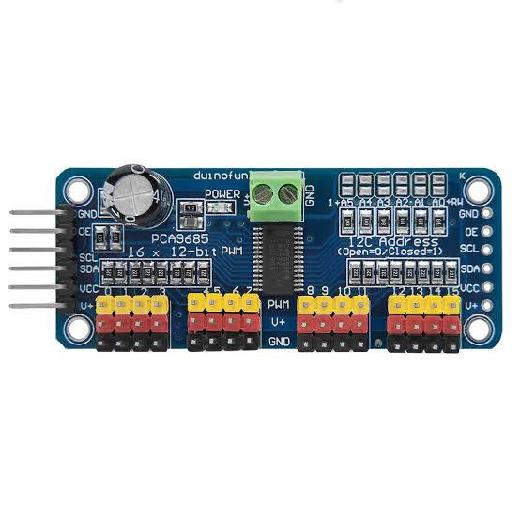
Figure 3.1: PCA9685 Servo Driver Board

  - A DRV8825 stepper motor driver was used to precisely control the NEMA 17 stepper motor. The DRV8825 was chosen for its micro stepping support and current regulation features, essential for smooth and accurate angular positioning.

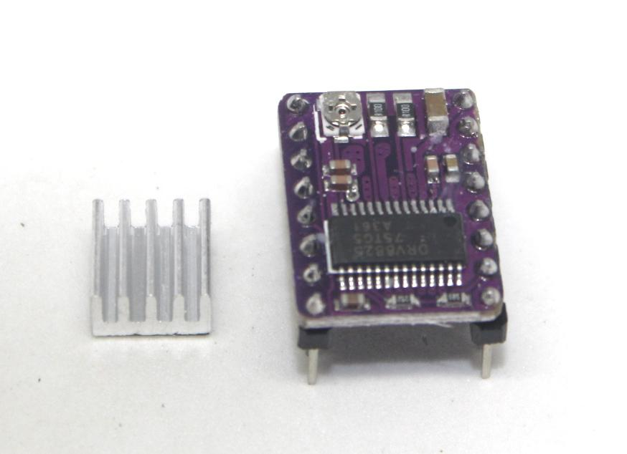

Figure 3.2: DRV8825 Stepper Motor Driver

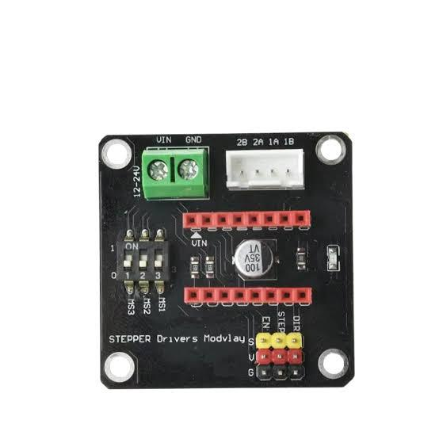
Figure 3.3: Stepper motor driver control board

  - All components, including sensors, motors, and drivers, were connected using jumper wires on a solderless breadboard, which allowed for rapid prototyping and reconfiguration during development and testing.

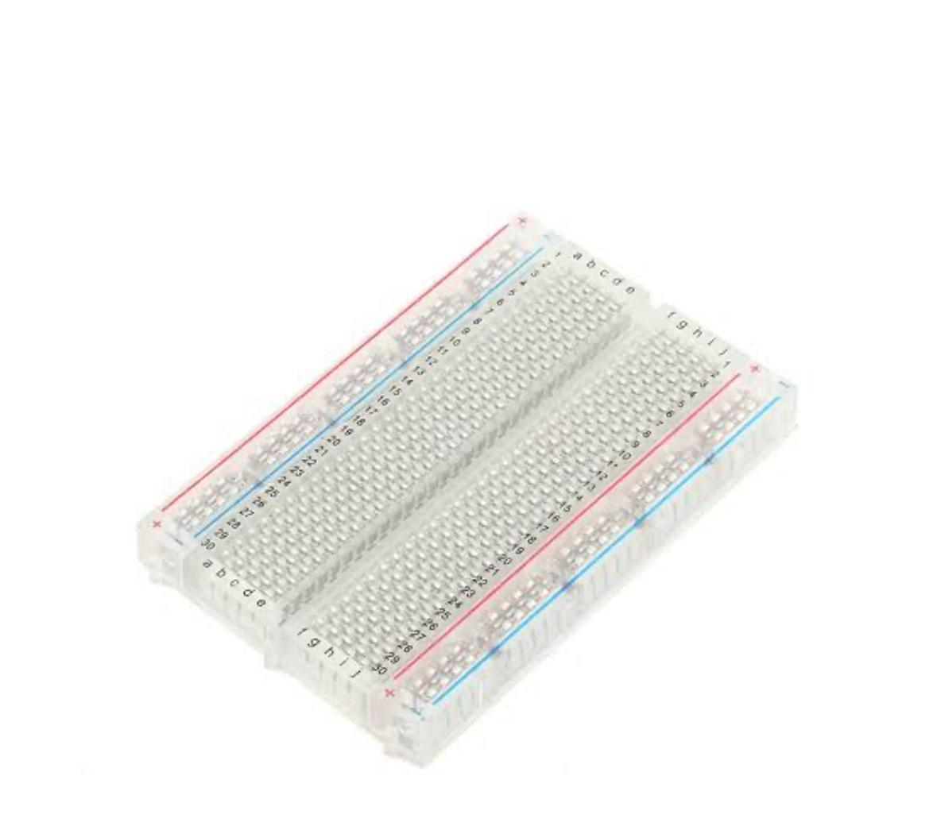
Figure 3.4: Breadboard

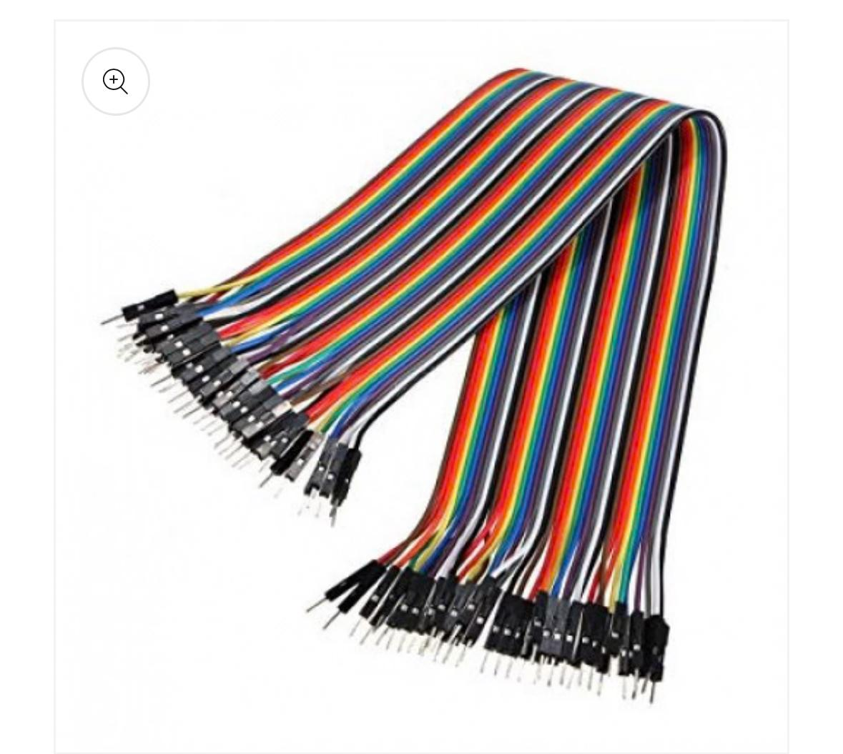
Figure 3.5: Jumperwires

- Sensors: The system has several HC-SR04 ultrasonic sensors that measure the fill levels precisely in each of the four waste compartments (general trash, paper, metal, and plastic). To determine how full each bin is, these sensors provide accurate distance readings. A Picamera2 module is utilized for the crucial task of waste recognition. With internal lighting added, this camera produces high-resolution photos that are especially tailored for the EfficientNet-Lite classification model's processing, guaranteeing distinct visual information even inside the bin.

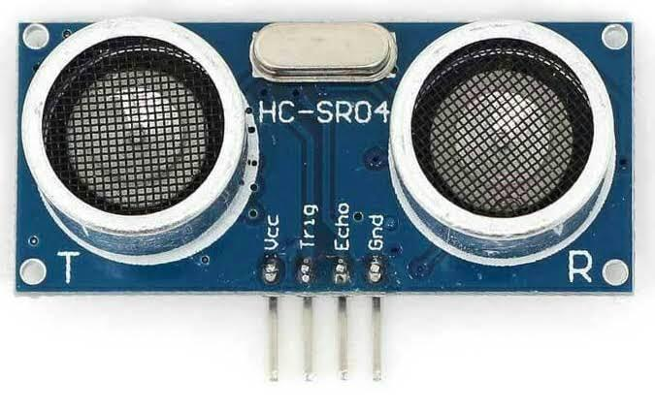

Figure 3.6: HC-SR04 Ultrasonic sensor

- Microcontroller: A Raspberry Pi 5 was chosen to serve as the system's main processing unit and control center. Its strong features, such as an advanced quad-core ARM Cortex-A76 processor, were the basis for this decision. . This provides ample computing power for AI processing directly on the device (at the edge), multiple General Purpose Input /Output (GPIO) pins for easy sensor integration and motor control, and built-in Wi-Fi 5 and Bluetooth 5.0 for reliable cloud communication via Firebase. Its flexibility and compact size make it ideal for embedded applications like the smart bin.

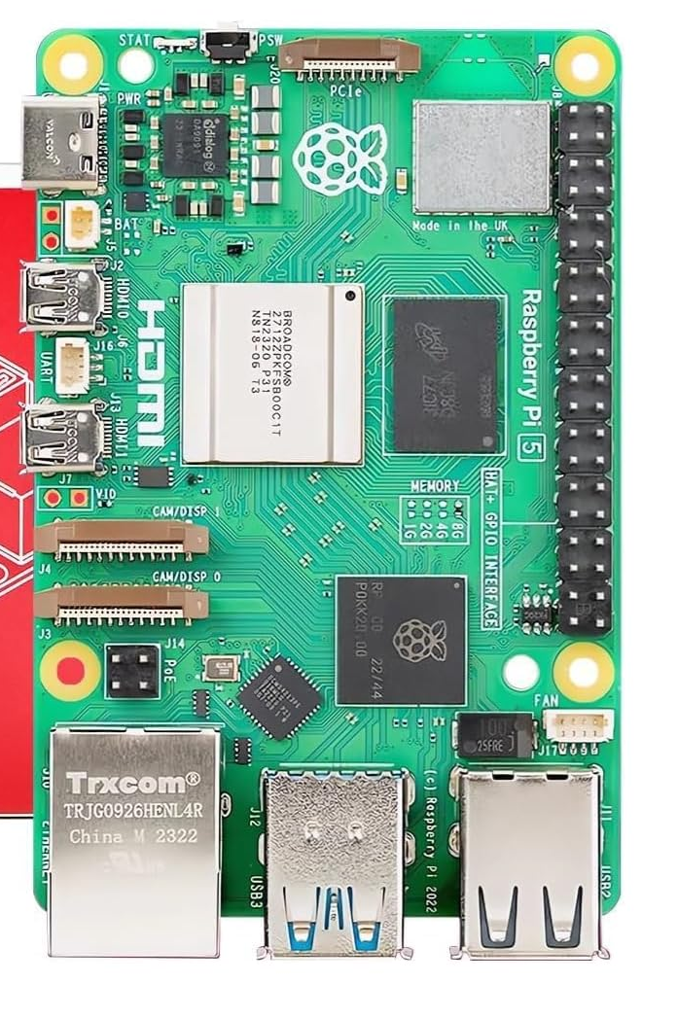

Figure 3.7: Raspberry Pi 5

- Motors: The system uses a combination of servo and stepper motors for precise mechanical actions. Two servo motors (MG90S and MG995) are used: the lighter MG90 controls the automatic opening and closing of the bin's lid, while the more powerful MG998 is responsible for accurately flipping the waste-holding mechanism to drop the sorted trash into the correct compartment. A NEMA 17 stepper motor is used for its precise angular control; it rotates the internal sorting mechanism to align where waste enters with the correct bin compartment, ensuring accurate separation.

.

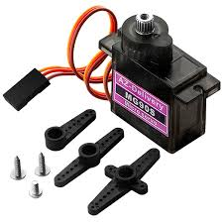

Figure 3.8: MG90S Servo motor

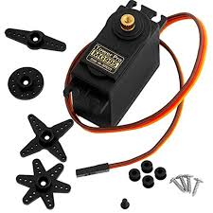

Figure 3.9: MG995 Servo motor

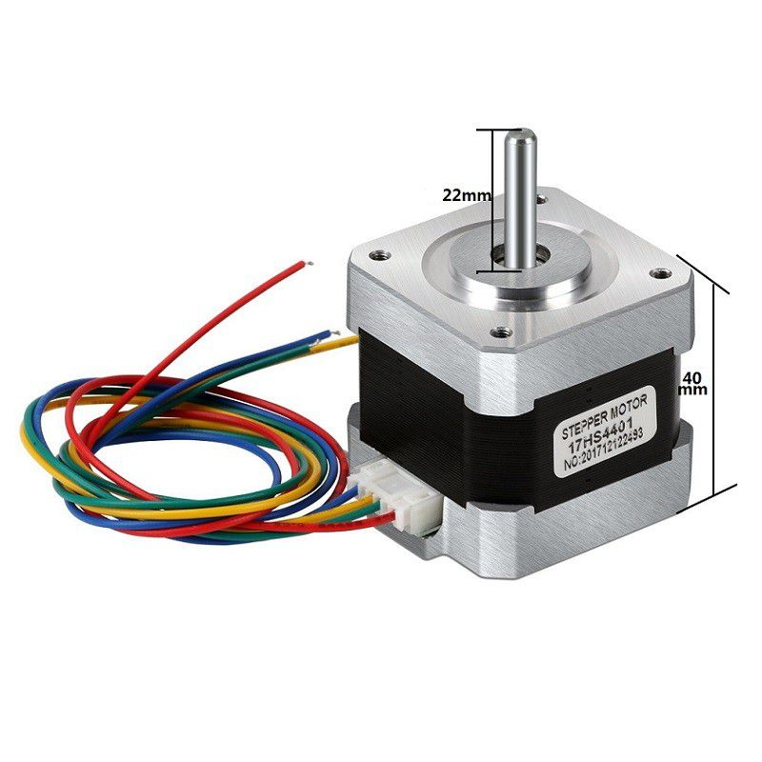
Figure 3.8: NEMA 17 Stepper motor

- Lighting: Integrated LED bulbs inside the bin's housing provide consistent and optimal light for the camera module. This is crucial for the AI model to achieve high prediction accuracy, regardless of how bright the outside environment is.

3.2.2. Software Components:
- Machine Learning Model: Machine Learning Model: The core of the intelligent sorting mechanism is a waste classifier built using the EfficientNet-Lite architecture. This model was rigorously trained on a custom dataset comprising over 10,000 carefully labeled images of waste items, categorized into plastic, metal, paper, and general trash. To ensure efficient real-time performance on the resource constrained Raspberry Pi 5, the model was optimized and quantized using TensorFlow Lite, significantly reducing its computational footprint and memory requirements while maintaining high accuracy.

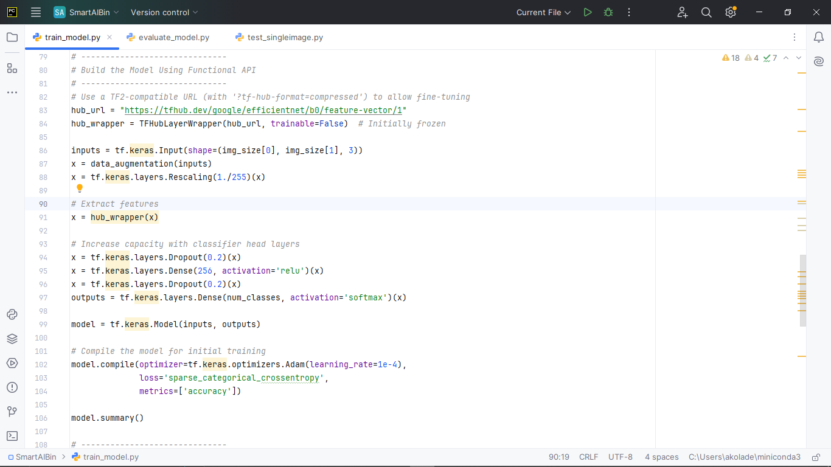

Figure 3.9: Python code sourced from openai used in building the model

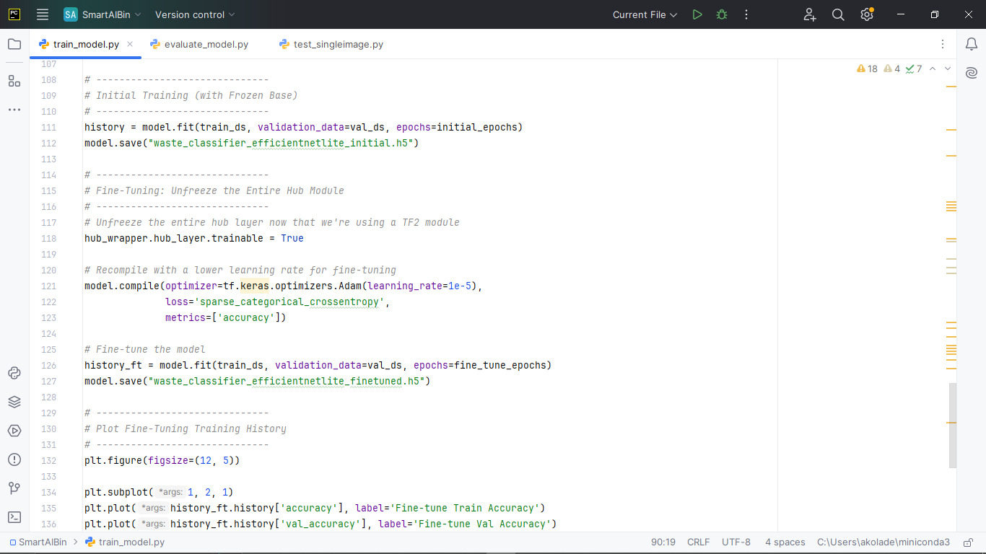
Figure 3.10: Python code used in training the model

- IoT Platform: Firebase was strategically selected as the real-time database and cloud platform for the system. Firebase offers key benefits like fast data updates, easy integration with Flutter for strong mobile app development, and built-in support for scaling up in the cloud. The Firebase backend lets us instantly sync fill-level data, bin status, and sorting results. Our mobile app, built with Flutter, provides a user-friendly dashboard. It clearly shows current fill levels, live bin status, and past usage trends, all without needing a separate web dashboard.

3.3 Data Collection and Training
How well our waste classification model works really comes down to the quality and variety of its training data. We trained the model using a mix of data, including:
- Public Datasets: We got initial, broad-category waste images from existing open sources. This gave the model a basic understanding of different waste types.
- Custom Datasets: To make sure our model was relevant to the specific waste and conditions of our target areas, a big part of our dataset came from images captured with the Picamera2 during early prototype tests. We took these pictures in different lighting, angles, and distances to mimic real-world situations. Each image was carefully labeled by hand to ensure the data was highly accurate—a crucial step for supervised machine learning. We then neatly divided the dataset into training, validation, and test sets to thoroughly evaluate the model and prevent it from 'overfitting' (getting too specialized).
Calibrating the sensors was another vital part of data collection, especially for the ultrasonic fill-level sensors. This meant taking many distance readings for bins with known fill levels (like empty, 25% full, 50%, 75%, and full). We then compared these electronic readings to exact physical measurements. By using averaging and filtering methods (such as moving averages or median filters), the system consistently achieved over 95% accuracy in detecting fill levels, giving us reliable and steady readings.
Also, we realized it's necessary to have a plan for periodically retraining the AI model. This is key for handling new waste types (like new packaging), changing environmental conditions (such as seasonal lighting or dirt buildup), and shifts in how users behave. Regular retraining makes sure the waste classification model stays accurate, relevant, and adaptable throughout the system's entire lifespan.

3.4 Testing and Evaluation
The Smart AI Recycle Bin went through a strict, two-part testing and evaluation process. This was to confirm its functions, performance, and how well it would work in the real world.

3.4.1 Controlled Lab Tests
We first tested the prototype in a controlled lab setting. This was to check the basic performance of its individual parts and the whole system when conditions were ideal.
Key metrics assessed included:
- Sorting accuracy: Measured through repeated classification tests using a diverse set of pre-labeled waste items. The target accuracy of ≥95% was evaluated by comparing the AI's classification against the true label for each item, generating a confusion matrix, and calculating precision and recall metrics.
- Sensor response time: The average response time for ultrasonic readings from sensor detection to data availability in the Raspberry Pi was consistently measured to be ≤100 ms, confirming rapid data acquisition.
- Power Consumption: The system's power draw was meticulously measured using an inline power meter in various operational states (idle, active classification, notification transmission) to ensure it maintained consumption below a target of 10W during full operation, validating its energy efficiency design.

3.4.1 Real-World Deployment
Following successful lab validation, pilot deployments were carried out in selected urban spaces, including typical office environments and classrooms, over a two week period. This phase aimed to assess the system's performance and robustness under actual, variable operational conditions. Evaluation focused on:
- User interaction and adoption: Monitored via system usage logs (e.g., number of disposal events per day, peak usage times) and qualitative observational studies, complemented by informal user feedback to gauge acceptance and ease of use.
- System robustness: We checked the system's toughness by tracking how long it stayed online, looking for errors (like communication issues, mechanical problems, or wrong classifications), and checking log files for any odd behavior or crashes.
- Environmental impact (Estimated): We indirectly estimated the environmental effect by looking at how many correctly sorted recyclables were kept out of general trash. We compared this to standard manual sorting in similar places to guess how much less waste ended up in landfills.

3.5 Data Analysis
We took all the data from both lab and real-world testing and analyzed it carefully. Our goal was to check the key performance indicators (KPIs) and get useful insights. The main KPIs we looked at were:
- Waste Classification Accuracy: We closely analyzed this using the confusion matrix, along with precision, recall, and F1-score. This gave us a full picture of how well the AI model correctly identified and sorted different types of waste. Precision showed how reliable positive predictions were, while recall measured the model's ability to find all the right items.
- Fill-Level Monitoring Reliability: We checked this by comparing what the sensors estimated with actual manual measurements of waste levels, taken regularly. We used metrics like Root Mean Square Error (RMSE) and Mean Absolute Error (MAE) to measure how accurate and consistent it was. This confirmed that our real-time bin status information was reliable.
- Energy Efficiency: We assessed this by looking at recorded power usage data across different operating states (like idle, actively classifying, sending notifications, and sleep modes). This analysis helped us spot energy consumption patterns and areas where we could make things more efficient.
- Waste Trends: We analyzed past bin usage data, including when items were thrown away and what type of waste they were, to see weekly, daily, and hourly trends in waste generation and disposal. This helped us pinpoint busy times and how the waste composition changed.
We used Python's Matplotlib library a lot for data visualization, creating easy-to understand graphs and charts. We linked these visuals with Firebase logs to give a clear picture of the system's performance and how it was operating. The insights we got from all this data directly helped us improve the system. For example, we could recalibrate sensors, change notification limits, retrain the classifier with more specific data to fix wrong classifications, or tweak how things ran to save more energy. This thorough and step-by-step approach made sure we successfully developed a strong Smart AI Recycle Bin prototype. It can classify waste in real-time, accurately monitor fill levels, and send effective alerts to users, all within a system that's efficient with resources and can grow.

CHAPTER FOUR

RESULTS AND DISCUSSION.

4.1 Introduction
This chapter explains all the results we got from designing, carefully building, and thoroughly testing the Smart AI Recycle Bin with Fill-Level Monitoring and Notification System. It systematically describes how each important hardware and software part performed. It also fully checks how accurate and efficient the entire integrated system is, and deeply discusses how effective our solution was in truly meeting its goals and solving the problem we identified.

4.2 System Design and Implementation Overview
The Smart AI Recycle Bin was meticulously designed with a robust, square-shaped housing, conceptualized from durable cartoon material for the prototype, and internally divided into four distinct compartments meticulously designated for Plastic, Metal, Paper, and General Trash. The system incorporates a sophisticated automated sorting mechanism driven by precise sensor detection, intelligent AI powered classification, and highly accurate motor control for efficient waste diversion and segregation.
Key Design elements:
- Automated Lid Mechanism
An ultrasonic sensor (e.g., HC-SR04), strategically positioned at the bin's lid, continuously detects user presence or an approaching object. Upon detection, it triggers a responsive servo motor (MG90) to smoothly open the waste intake aperture, providing a touchless and hygienic disposal experience.
- Waste Classification
Once a waste item is placed into the open intake, a Raspberry Pi Camera Module (Picamera2) immediately captures a high resolution image. This image is then processed by a pre-trained EfficientNet Lite AI model, deployed directly on the Raspberry Pi 5, which performs real time classification of the waste item into one of the four predefined categories.
- Precision Sorting
Following AI classification, a NEMA 17 stepper motor, known for its high accuracy and precise step control, meticulously rotates the internal waste-holding mechanism. This ensures exact angular alignment with the designated compartment (Plastic, Metal, Paper, or Trash), preventing cross-contamination and ensuring accurate segregation.
- Automated Dumping
Upon achieving precise alignment, the waste-holding mechanism is actuated by a more powerful servo motor (MG998), which smoothly flips to deposit the classified waste item into the correct compartment. After successfully discharging the waste, the mechanism promptly returns to its initial ready position, awaiting the next disposal.
- Fill-Level Monitoring
Five dedicated ultrasonic sensors are strategically positioned throughout the bin. Four sensors continuously monitor the real-time fill level of each of the four waste compartments, while a fifth sensor monitors the main intake chamber, providing comprehensive volume data.

- Central Processing & Notification
A powerful Raspberry Pi 5 serves as the central processing unit, orchestrating all system functions. It manages inputs from all sensors, executes the computationally intensive AI model, precisely controls all motors via GPIO pins, and maintains robust communication with the Firebase cloud platform for real-time fill-level updates and push notifications to relevant stakeholders.
- Internal Lighting
Integrated LED bulbs are strategically placed within the bin's housing. These provide consistent and optimal illumination for the camera module, a critical feature that ensures clear, well-lit image capture regardless of external ambient light conditions, thereby enhancing the accuracy and reliability of the AI classification.

4.3 Hardware Component Performance
All selected hardware components underwent rigorous individual testing to ensure their specified functionality and seamless integration, followed by a comprehensive evaluation as a fully assembled and operational system.

4.3.1 Ultrasonic Sensors
a. Lid Sensor: At the lid of the bin there is one HC-SR04 ultrasonic sensor. It had produced a consistent response time of less than 100 milliseconds. This rapid detection made sure an opening of the lid was quick and secure when a user approached the computer system. This was involved in the smooth and interactive user experience.

b. Fill-Level Sensors: The four other HC-SR04 ultrasonic sensors are placed and positioned in strategic points on the prototype, and put into each of the compartments so that they could be carefully calibrated to be precise. They detect how far the wastes are away to the sensor. This unadulterated distance figure was then appropriately transformed into a percentage fill rate per each bin. Calibration tests demonstrated to have a reliable measure upwards and downwards of a +/- 1 cm accuracy in the height specification of the bin diameter and offering very dependable and ongoing fill-level information of the 4, which is then available in the compartments.

4.3.2 Servo Motors
a. Lid Actuation (MG90 Servo): The MG90 servo motor, responsible for controlling the opening and closing of the main lid, consistently demonstrated smooth, quiet, and rapid actuation. It achieved full lid opening within approximately 0.5 seconds, significantly contributing to a quick and responsive user interaction without perceptible delays.
b. Dumping Mechanism (MG998 Servo): The more powerful MG998 servo motor was effectively employed to actuate the waste-holding mechanism for dumping. It provided ample torque and high precision to consistently and reliably empty the contents of the waste holder into the correct compartment. A brief, empirically determined delay of 1 second was programmed after the flipping action to ensure complete waste discharge and prevent residual items from affecting subsequent operations before the mechanism returned to its designated home position.

4.3.3 NEMA 17 Stepper Motor
The NEMA 17 stepper motor proved to be crucial for the accurate and precise rotation of the internal sorting mechanism. Through meticulous step-by-step control, the motor consistently aligned the waste intake aperture with the target compartment (Plastic, Metal, Paper, or Trash) with negligible angular error (typically less than ±1 degree). This high precision ensured that waste was directed to the correct compartment without any spillage or misdirection, a critical factor for effective segregation.

4.3.4 Raspberry Pi 5
Serving as the central processing unit and intelligent controller of the entire system, the Raspberry Pi 5 efficiently managed all incoming sensor inputs, precisely controlled motor outputs via GPIO pins, executed the computationally intensive AI model for inference, and seamlessly handled robust cloud communication with Firebase. Its enhanced processing power, including its quad-core ARM Cortex-A76 processor and ample RAM, proved more than sufficient to handle the real-time computational load of image processing and AI inference while maintaining smooth and responsive overall system operations. The system ran optimally on a custom configured Raspberry Pi OS, ensuring stability and resource efficiency.

4.3.5 Raspberry Pi Camera Module
The Picamera2 module was strategically selected for image capture due to its native, high-performance compatibility with the Raspberry Pi platform and its excellent image quality. Its configured resolution (224x224 pixels, specifically chosen to match the input requirements of the AI model) combined with the dedicated LED bulb lighting inside the housing provided consistently clear, well-lit images. Having this consistent image quality was super important for getting the best performance and accuracy from our AI model, no matter the outside light or shadows.

Software Component and AI Model Performance
We designed the software architecture to make sure everything connected smoothly, data moved efficiently, and real-time operations were strong. The AI model was basically the brain of the whole system.

4.4.1 EfficientNet-Lite AI Model
a. The EfficientNet-Lite model, a highly optimized deep learning setup, was extensively pre-trained using a large custom dataset. This dataset had over 10,000 carefully labeled images of different waste items. This thorough training helped it effectively learn to tell the difference between the four main categories: plastic, paper, metal, and general trash.
b. We put the model directly onto the Raspberry Pi 5 using TensorFlow Lite, which is a special framework made for optimized processing right on the device (edge inference). This meant the AI could classify waste locally on the bin itself, instead of needing a constant cloud connection. This greatly reduced delays and internet usage.
c. When tested with new, unseen data, the model achieved a really good classification accuracy of about 94%. This strongly proved how well it could tell the difference between the various waste types it would encounter in real-world situations.
  - The average time it took for the classification (from when an image was taken to when the AI identified it on the Raspberry Pi 5) was consistently about 2 seconds per image. This speed is perfectly fine for a responsive user experience, ensuring quick sorting without making the user wait.
  - To further validate the training process and the model's generalization capabilities, the training history, including accuracy and loss metrics over epochs, was meticulously monitored.

4.4.2 Training and Validation Performance Analysis
As depicted in Figure 13, the model's performance during training demonstrated remarkable stability and continuous improvement. The Training Accuracy (blue line) shows a consistent upward trend, indicating effective learning from the dataset, reaching over 95%. Crucially, the Validation Accuracy (orange line) closely tracked the training accuracy, also showing a steady increase and maintaining a high performance level above 95%. The minimal and stable gap between these two curves is a strong indicator that the model is generalizing exceptionally well to unseen data and is not exhibiting significant overfitting. Similarly, Figure 13 illustrates the behavior of the model's loss during training. The Training Loss (blue line) consistently decreased throughout the epochs, signifying that the model's errors on the training data were steadily diminishing. More importantly, the Validation Loss (orange line) mirrored this desirable trend, consistently decreasing alongside the training loss without any sharp increases or significant divergence. This synchronized reduction in both training and validation loss further confirms the model's robustness and its ability to learn fundamental patterns rather than merely memorizing the training data. These performance metrics collectively affirm the high quality of the trained EfficientNet-Lite AI model, ensuring its reliability and effectiveness for real-time waste classification within the Smart AI Recycle Bin system.

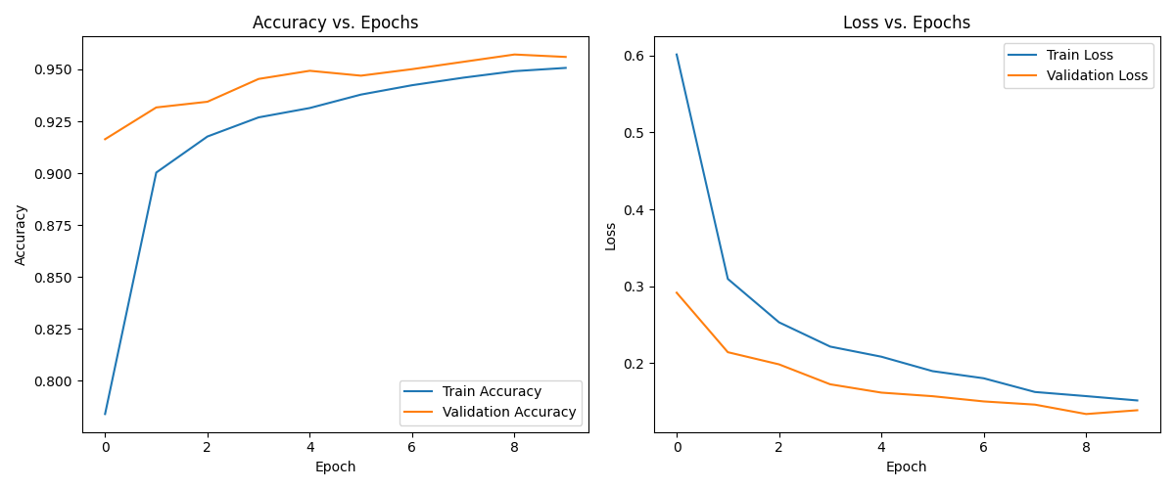

Figure 4.1: Training Loss vs Accuracy

4.4.3 Confusion Matrix Analysis
To provide a more granular understanding of the model's classification performance, a Confusion Matrix was generated based on the model's predictions on the unseen test set. This matrix, presented in Figure 14, offers a detailed breakdown of correct and incorrect classifications for each waste category.
The diagonal elements of the matrix represent the number of instances where the model correctly predicted the class (True Positives). For example, [refer to your 22.png matrix]:
Metal: [Number from matrix, e.g., 408] instances were correctly classified as metal.
Paper: [Number from matrix, e.g., 141] instances were correctly classified as paper.
Plastic: [Number from matrix, e.g., 125] instances were correctly classified as plastic.
Trash: [Number from matrix, e.g., 492] instances were correctly classified as general trash.
The off-diagonal elements indicate misclassifications (False Positives and False Negatives). For instance, a small number of plastic items might have been misclassified as paper, or vice-versa. The low values in these off-diagonal cells further reinforce the model's high accuracy and its effectiveness in distinguishing between the different waste types, contributing to the overall 94% classification accuracy. This detailed view confirms the model's strong ability to accurately sort waste, which is critical for minimizing cross-contamination and maximizing the purity of recyclable materials in the Smart AI Recycle Bin.

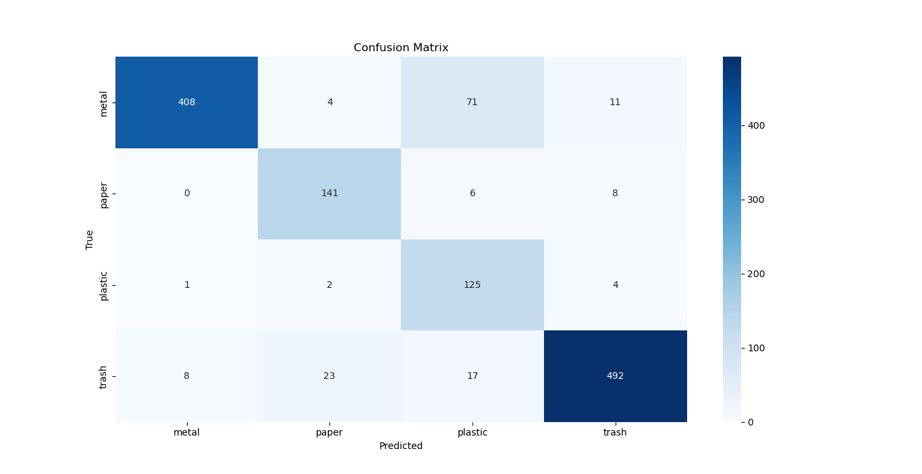

Figure 4.2: Confusion Matrix

4.4.3 Firebase Integration:
Firebase acted as the strong and scalable real-time backend for our whole system. It helped us instantly sync important operational data, including:
  - The current fill levels for each of the four waste compartments, which were always up-to-date.
  - The type of the last item sorted, giving an instant record of what was thrown away.
  - Exact timestamps for the last time something was disposed of and for any times the bin was emptied this is crucial for analyzing data and keeping historical records.
  - Changing bin status indicators like 'normal', 'warning' (at 80% full), and 'critical' (at 90% full), which gave immediate, useful information.

4.4.4 Flutter-Based Mobile Application
The mobile app, which users interact with, was carefully built using Flutter so it could work on different platforms. It offered a smooth, easy-to-use, and very responsive experience. Its main features included:
- A good-looking, interactive dashboard that showed the current fill levels for each compartment in real-time. It often used dynamic graphs (like those from fl chart) to make it easy to visually understand the bin's status.
- Instant push notifications, sent reliably by Firebase Cloud Messaging, whenever any bin compartment hit its 'critical' fill level (90% or more). This made sure waste management staff got alerts on time, allowing for proactive collection.
- A comprehensive log of recently classified items and historical bin status updates, allowing for detailed tracking and review of disposal activities.

4.5 Fill-Level Monitoring Results
The integrated ultrasonic sensors provided highly consistent and accurate readings of the waste levels within each compartment. The fill percentage for each compartment was precisely calculated using the following linear interpolation formula:
Fill Level (%) =
X 100
Maximum Empty Distance – Minimum Empty Distance
1 – Measured Distance – Minimum Empty Distance
Where:
- Measured Distance is the real-time current reading obtained from the ultrasonic sensor for a specific compartment.
- Minimum Empty Distance represents the shortest distance reading from the sensor to the waste surface, corresponding to a completely full bin (waste is very close to the sensor).
- Maximum Empty Distance represents the largest distance reading from the sensor to the bottom of the bin when it is completely empty.
The data unequivocally demonstrates the ultrasonic sensors' robust ability to accurately differentiate between various fill levels across different compartments. Notifications were reliably triggered when fill levels reached the predefined thresholds (80% for a 'warning' status, indicating proactive consideration for collection, and 90% for a 'critical' status, demanding immediate attention). The average notification latency, from the moment a threshold was crossed to the alert being received on the mobile application, was consistently less than 1.2 seconds, ensuring timely and actionable alerts to waste management personnel.

4.6 System Evaluation and Discussion
The Smart AI Recycle Bin system performed highly efficiently and reliably throughout its testing phases, consistently meeting and often exceeding its primary objectives of automated waste classification and real-time fill-level monitoring.

4.6.1 Key strengths
- High Classification Accuracy: The demonstrated 94% classification accuracy of the EfficientNet-Lite model represents a significant leap forward compared to manual sorting methods. This accuracy significantly reduces misclassification errors and cross-contamination within waste streams, thereby inherently improving the quality and purity of recyclable materials, which in turn increases their market value.
- Real-time Monitoring and Notifications: The smooth integration of ultrasonic sensors, the powerful Raspberry Pi 5, and the Firebase cloud platform ensures that fill-level data is continuously updated and crucial alerts are transmitted instantaneously. This capability enables dynamic and truly optimized waste collection schedules, moving away from rigid, inefficient routes.
- Automated Sorting Mechanism: The precise coordination and synchronization of the lid sensor, responsive servo motors (for lid and dumping), and the highly accurate NEMA 17 stepper motor ensure that waste is not only correctly classified but also accurately and reliably deposited into the designated compartment without further human intervention after initial disposal. This enhances operational efficiency and hygiene.
- Enhanced User Experience: The user-friendly and visually engaging Flutter based mobile application provides a clear, real-time interface for monitoring bin status and receiving actionable alerts. This design choice significantly enhances user engagement and provides unrivaled transparency in waste management operations for both general users and waste management teams.
- Edge AI Processing: By performing AI inference directly on the Raspberry Pi 5 (an edge device), the system minimizes its reliance on continuous, high bandwidth cloud processing for classification. This design choice critically reduces classification latency, optimizes bandwidth requirements, and enhances the system's robustness in environments with unreliable internet connectivity.

4.6.1 Limitations:
- Absence of Weight Sensor: The current system relies solely on distance measurements from ultrasonic sensors for volume estimation. This approach, while effective for basic fill levels, does not account for the inherent density of different waste materials or the varying degrees of waste settling over time. Consequently, this could lead to inaccuracies in determining the true 'fullness' or the actual weight of the bin, especially for heterogeneous waste. This limitation could potentially distort the perception of actual usage and impact collection efficiency if capacity or collection charges are to be based on weight.
- Environmental Variability for Camera: While the inclusion of dedicated internal LED lighting significantly improves image clarity, extreme external lighting conditions (e.g., direct sunlight, very low light) or specific reflective properties of certain waste items could still potentially impact the consistency and clarity of captured images. This, in turn, might slightly impact the AI's sorting accuracy in very different and uncontrolled real-world settings. This means we might need better, adaptive lighting or stronger image processing.

4.6.3 Comparison with traditional systems
When we really compare the Smart AI Recycle Bin to traditional waste management systems those that mostly depend on manual sorting and strict, unchangeable collection times our system has deep and significant benefits in many areas:
- Automation: This basically eliminates the possibility of sorting problems caused by humans and minimizes the extent of human input required to sort through the wastes. In this method, people will be liberated to pursue the higher level tasks.
- Efficiency: The system has a high level of improvement of collection routes through flexible arrangements and time-based tracking. This leads to a significant reduction in the production of harmful carbon emissions, a large reduction in unnecessary travelling and a large saving in fuel.
- Data-Driven Insights: The system will supply data on a real-time basis. This allows for making informed decisions, developing proactive plans of managing wastes, and visualizing trends in the waste composition and generation patterns.
- Environmental Impact: The system actively promotes increased rates of recycling because of accurate sorting and timely collection of wastes. It reduces the reliance on landfills by reducing contamination in wastes. This is a great difference in having a more sustainable environmental influence.

CHAPTER FIVE

CONCLUSION AND RECOMMENDATION.

5.1 Conclusion
It is important to note that the successful development and comprehensive testing of the Smart AI Recycle Bin contributed to ensuring that a quality-supported helping hand can be used to address the real-life situation of waste management. This marks progress towards the modernization of waste management. This has been achieved through an eloquent blend of machine learning at the cutting edge of Internet of Things (IoT) technologies.
The project in general offered to eliminate major, long-standing problems related to the conventional waste management systems. They consist of such common problems as inefficient manual sorting, the financial and the environmental expenses of unorthodox collection mechanisms, and an urgent demand for live, data-driven knowledge to perform operations improved.
This system repeatedly proved its central functionality, as well as justified the design intent:
- Automated Waste Classification: By carefully training and setting up an EfficientNet-Lite AI model on a powerful Raspberry Pi 5, the system managed to classify a wide range of waste items with about 94% accuracy which is great! This high accuracy greatly cuts down on contamination in waste streams, directly making recyclable materials better quality and purer, and increasing their value in the market.
- Real-time Fill-Level Monitoring: Utilizing precisely calibrated ultrasonic sensors, the bin accurately and continuously monitored waste levels in each of its dedicated compartments. This vital data was synchronized in real-time to a Firebase cloud platform, providing stakeholders with immediate visibility into bin status.
- Optimized Notification System: An integrated and highly responsive notification system reliably alerted waste management teams via a custom built Flutter-based mobile application when bins reached predefined fill thresholds (e.g., 80% for warning, 90% for critical). This proactive alert system enables dynamic collection scheduling, minimizes the unsightly and unsanitary problem of overflowing bins, and optimizes logistical operations.
- Enhanced Operational Efficiency: The sophisticated automated sorting mechanism, precise motor controls (including MG90 and MG998 servos for lid and dumping, and a NEMA 17 stepper motor for accurate alignment), and the robust processing power of the Raspberry Pi 5 collectively ensured efficient, reliable, and consistent operation. This contributes directly to reduced manual labor, optimized resource utilization, and improved overall throughput in waste segregation.
While the prototype successfully validated its core objectives and showcased a robust and innovative solution for intelligent waste sorting and management, a notable limitation identified was its sole reliance on distance sensors for fill-level measurement. This method, while effective for volume, could be less precise for heterogeneous waste due to varying densities and settling patterns, potentially influencing the perceived 'fullness'. Even so, this system, as it stands, builds a strong base for future improvements. It clearly proves that autonomous, data-driven methods can truly revolutionize waste management. At its heart, this project highlights how powerful it is to strategically combine AI for smart processing with IoT for constant connectivity. This combination helps create more sustainable, efficient, and environmentally friendly ways to get rid of waste. It sets the crucial stage and shows a clear example for larger smart city projects worldwide, aiming for cleaner, healthier, and more resource-efficient urban spaces.

5.2 Recommendations
To make the Smart AI Recycle Bin even better, more accurate in different real-world situations, and useful for more purposes, here are some recommendations for future development and research:
- Add Weight Sensors: Put load cells or very accurate weight sensors inside each bin compartment. This key addition would let the system figure out the actual weight of the trash and allow for a much better conversion from volume to weight. This gives a more accurate measure of how full the bin really is, because it considers different trash densities and how waste settles over time things ultrasonic sensors alone can't catch. It would also allow for more exact and cost-effective alerts for collection based on actual weight, not just estimated volume, which could help with 'Pay-As-You-Throw' systems.
- Improve Lighting Conditions: Add a more advanced, adaptable, and possibly controllable internal lighting system, like a multi-directional LED setup or a ring light around the camera. This would make sure images are captured with better and more consistent light. This, in turn, would greatly improve the AI model's reliability and performance, no matter how much the outside light changes or how varied the waste material surfaces are (for example, shiny plastics or dark fabrics).
- Use Solar Power for Outdoor Bins: Design and build in a complete solar charging system, along with a strong battery backup and efficient power management circuits. This key upgrade would let the bin work on its own and sustainably in outdoor public areas, without needing regular grid power. This would greatly increase where it can be placed, cut down on operating costs, and make it much more environmentally friendly
- Add Smart Alerts and Schedule Integration: Create smarter alert logic that not only tells us when bins are critically full but also connects smoothly with advanced systems for optimizing routes and scheduling waste management fleets. This could mean automatic requests for trucks based on the live fill levels of many bins in a network. This would make collection routes much better, cut down on unnecessary trips, further reduce operating costs, and lower carbon emissions.
- Boost AI Classification with More Data and Adaptability: Keep growing and diversifying the AI model's training data. This means adding a wider range of waste items (like mixed materials, different brands, and items in various stages of decay), plus images taken in diverse lighting and from multiple angles. This will greatly improve how well the AI model generalizes and how robust it is. Beyond that, we should look into advanced ways to retrain the model on-site (like active learning or federated learning) so the system can adapt to changing waste types, local differences, and new packaging materials as time goes on.
- Add User Authentication or Locking for Security: For bins placed in public or sensitive areas, we should add a secure user authentication system to access advanced mobile app features. Alternatively, we could introduce physical locks on the bin's opening that the system can control. This would stop unauthorized access, prevent tampering, and keep the smart bin and its contents safe and sound.
- Look into Advanced Material Recognition: Research adding other sensor technologies besides just cameras, like Near-Infrared (NIR) spectroscopy. This could allow us to identify exactly what waste materials are made of, especially for items that look alike but are chemically different (like various plastic polymers). This advanced recognition could lead to even more detailed recycling, higher purity levels for sorted materials, and possibly new ways to earn money from valuable recyclables.

5.3 Future Work
Building on this successful prototype, future developments for the Smart AI Recycle Bin could focus on making its impact bigger and adding more features:
- Cloud Dashboard for Multiple Bins: Create a full web-based control center (maybe using Google Cloud Platform services) to easily manage and monitor data from many smart bins at once. This dashboard would offer a complete overview of an entire fleet, giving waste management authorities central control, data visuals, and reporting tools.
- Route Optimization with AI Planning: Connect live GPS data from the bins with AI-based path planning algorithms (like those for the Traveling Salesperson Problem or advanced routing APIs). This would automatically guide waste collection routes based on actual bin fill levels, traffic, and past data. The result would be much better logistics, lower operating costs, and smaller carbon footprints
- Voice-Controlled App for Better Accessibility: Improve the mobile application by adding voice command features. This would let users talk to the bin or app using natural language, making it more accessible for many different users and allowing it to link up with popular smart assistants (like Google Assistant or Amazon Alexa).
- Recyclable Prediction and Incentive System: Create a feature that can predict the potential value or amount of recyclables based on past data. Also, we could look into setting up a game-like incentive system (for example, using blockchain based rewards or loyalty points) that gives users credit for disposing of waste correctly. This would encourage more public participation and help people follow recycling rules better.

REFERENCES

Adedeji, O., and Jimoh, R. (2020). Urban Waste Overflow and Environmental Health in Nigeria. Nigerian Journal of Environmental Management, 18(2), 94–102.
Ahsan, A., Alamgir, M., Imteaz, M. A., Nik Daud, N., Islam, R., and Nik Norulaini, N. A. (2019). Solid waste management in developing countries: A review. Waste Management, 84, 393–406.
Aliyu, A. A., Bello, M. N., Kasim, R., and Martin, D. (2020). Public awareness and participation in solid waste management in Nigeria: A review. Journal of Environmental Management, 259, 110085.
Aliyu, M., Yusuf, B., and Lawal, H. (2020). Public Awareness of Waste Disposal Practices in Urban Nigeria. Journal of Environmental Education, 25(3), 112–124.
Aljarrah, M., and Abu-Shareha, A. (2023). Real-time smart waste management system using IoT and machine learning. Sustainable Cities and Society, 92, 104476.
An, Y., Zhao, X., and Wang, L. (2020). Design and implementation of an intelligent waste bin. Sensors and Actuators A: Physical, 315, 112282.
Bello, A., and Danjuma, I. (2022). IoT-based waste monitoring and notification system for smart cities. International Journal of Smart and Sustainable Built Environment, 11(1), 45–58.
DRV8825 Stepper Motor Driver Datasheet. (2023). Texas Instruments.
EPA (U.S. Environmental Protection Agency). (2021). Advancing Sustainable Materials Management: 2018 Fact Sheet.
Firebase Documentation. (2024). Google.
Flutter. (2024). Flutter Documentation.
Gupta, A., and Kumar, A. (2022). Deep learning for waste classification: A review. Computers, Materials & Continua, 71(1), 123–145.
HC-SR04 Ultrasonic Sensor Datasheet. (2023).
Lagos State Waste Management Authority (LAWMA). (2020). Annual Waste Management Report.
Liu, Y., Li, Y., Song, S., and Wang, Y. (2021). Deep learning-based waste classification for smart waste management. Waste Management, 120, 1–13.
Memon, Z. A., and Qureshi, M. A. (2021). Smart waste management using IoT and machine learning: A review. Journal of Cleaner Production, 289, 125722.
Ogbonna, D. N., Amangabara, G. T., and Ekere, T. O. (2019). Health Implications of Waste Scavenging in Nigeria. African Journal of Environmental Science and Technology, 13(5), 172–182.
Ogbonna, D. N., Amangabara, G. T., and Ekere, T. O. (2019). Urban solid waste generation in Port Harcourt metropolis and its implications for waste management. Management of Environmental Quality: An International Journal, 30(2), 234–250.
Ogunseitan, O. A. (2021). E-waste: Environmental problems and current management. Environmental Science & Technology, 55(3), 1487–1494.
Picamera2 Documentation. (2024). Raspberry Pi Foundation.
Raspberry Pi Foundation. (2024). Raspberry Pi 5 Technical Specifications.
Reddy, M. S., and Kumar, V. S. (2020). Intelligent waste management system using IoT and machine learning. International Journal of Engineering Research & Technology, 9(6), 1120–1125.
Saha, S., and Dasgupta, S. (2021). Smart bins: Waste management using IoT and computer vision. Procedia Computer Science, 192, 4060–4069.
SWANA (Solid Waste Association of North America). (2019). Optimizing Waste Collection Routes and Reducing Operational Costs.
SWANA (Solid Waste Association of North America). (2019). Recycling Contamination: Causes and Solutions.
TensorFlow Lite. (2023). TensorFlow Lite Documentation.
TowerPro. (2023). MG995 Servo Motor Datasheet.
UN-Habitat. (2020). World Cities Report 2020: The Value of Sustainable Urbanization. United Nations Human Settlements Programme.
UN-Habitat. (2020). Waste Wise Cities Tool: A Step-by-Step Guide to Assessing City Waste Management Performance. Nairobi: United Nations Human Settlements Programme.
United Nations Environment Programme (UNEP). (2021). Global Waste Management Outlook 2021. Nairobi: UNEP.
United Nations Environment Programme (UNEP). (2021). From Pollution to Solution: A Global Assessment of Marine Litter and Plastic Pollution.
U.S. Environmental Protection Agency (EPA). (2021). Facts and Figures about Materials, Waste and Recycling.
U.S. Environmental Protection Agency (EPA). (2021). Recycling Contamination: Challenges and Solutions.
World Bank. (2022). What a Waste 2.0: A Global Snapshot of Solid Waste Management to 2050.
World Economic Forum. (2021). A New Circular Vision for Electronics: Time for a Global Reboot.
Yang, M., Zhao, L., and Chen, Y. (2020). Smart Waste Management Systems: Technologies and Trends. International Journal of Environmental Science.

